Conversational AI Technical Approaches

Overview
In general, leading and managing AI projects requires a little more technical depth than traditional software, largely because the cost drivers used in determining a project’s ROI are significantly impacted by the technical approach you choose. Your technical approach will depend on many factors: your use case and your users’ tolerance for incorrect information, experience latency and outdated information, along with the stage of maturity of your project. This guide will help you consider your options and make appropriate tradeoffs.

What you'll do
- Understand Architectural Patterns for CAI systems
- Select an Approach
1

Understand architectural patterns for CAI systems
There are 3 main architectural approaches for developing conversational AI systems:
- Traditional, rules-based Natural Language Understanding (NLU) systems
- Standalone Large Language Model (LLM) chatbots like ChatGPT, Claude or LLAMA 2
- Hybrid systems that combine the NLU and LLM components
Let’s look at these approaches in more detail.
Natural language understanding (NLU) Systems
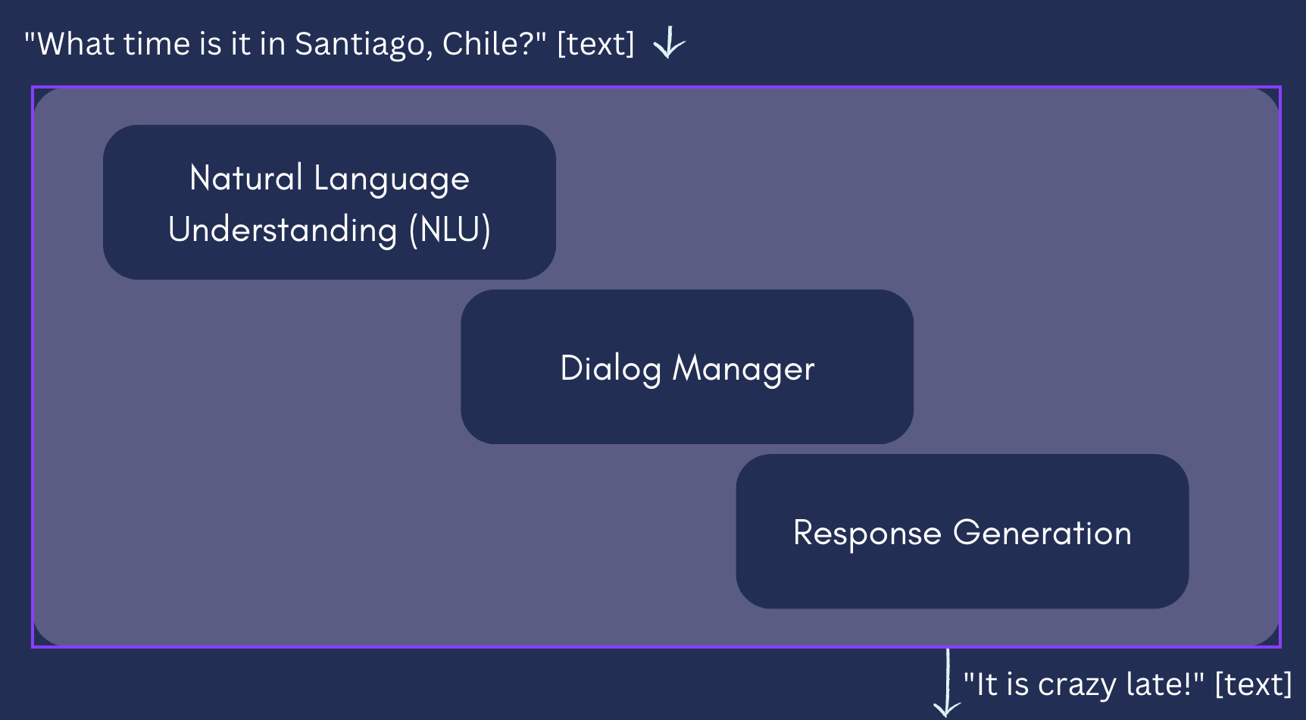
NLU systems use handcrafted rules and logic to determine conversation flow. These systems still use machine learning at various points, such as
- Automated Speech Recognition (ASR) to turn speech into text
- Classifying the user’s INTENT (what kind of request they are making, eg. ‘What is the weather?’ vs. ‘Turn on the lights!’)
- Extracting ENTITIES (objects information to complete the request, eg. Seattle in the request, ‘What is the weather in Seattle’) from speech, and understanding that it is a city
- Passing this information to a Dialog Management system, which tracks both conversation state (is this the first turn? what context has the user provided in the conversation so far) and the logic it should use for different requests
- Text to speech (TTS) systems that correctly create audio to ‘read out’ text answers from the underlying system.
However, the logic of conversation flow, context tracking and calling out to 3rd party systems as needed is usually all designed before the system is ever deployed to users, with programmatic control over these systems.
These systems have fallen out of favor with the dramatic adoption and popularity of Large Language Models (LLMs). They are resource-intensive to set up and keep up to date, as they involve highly-specified dialog flows for each use case you want to handle. However, they do have several advantages:
- More control over conversation flow and responses: these systems’ conversations are hand-written and pre-vetted. Any unintentional bugs or errors can be corrected directly.
- Inexpensive to run at scale: Once set up, the per-utterance and per-conversation costs can be dramatically lower than LLM-based systems.
- Robust security and data privacy controls: compared to LLMs, security and data privacy are mature and well-understood. Frameworks to set up NLU chabots have been used for years in large-scale enterprises with varying permission levels for their content, robust protections against hacking attempts, and data privacy policies in place.
StandaloneLarge Language Model Chatbots
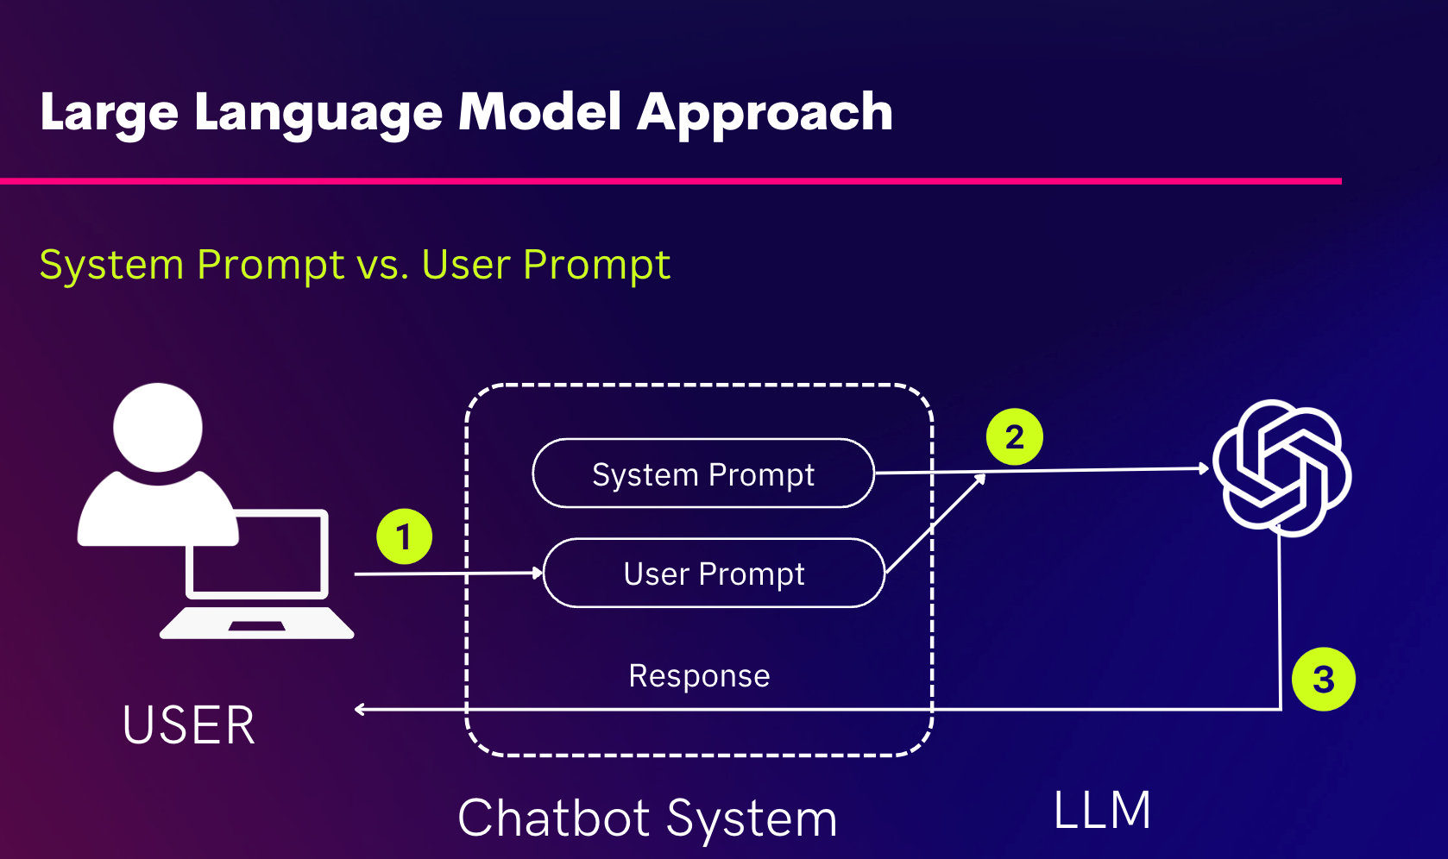
LLM chabots, like ChatGPT and OpenAI’s new Custom GPTs, are black boxes: there are no sub-systems responsible for different parts of the conversation flow, and the model itself provides natural language understanding, context handling, conversation state tracking, dialog management and response generation - all on one model. It is worth nothing that ChatGPT’s latest ‘voice-enabled models’ are really several models working in concert: their newly-released ASR model provides speech-to-text capabilities, while their TTS model Whisper provides text-to-speech. Google’s new Gemini model, meanwhile, is natively multimodal - meaning one model can generate text, images, and audio/voice.
In an LLM-based chatbot, the designer specifies the desired system behavior in a ‘system prompt’. This prompt is pre-appended to whatever the user inputs (in the ‘user prompt’) for each interaction with the LLM. We’ll examine some best practices in prompting in our live session!
The advantages LLM systems offer include:
- Handling of a broad variety of use cases with very little implementation effort. You simply specify the behavior and knowledge you want the system to have in the system prompt!
- Human-like flexibility in responses and dealing with unanticipated user requests
However, in practice they have proven largely impractical for enterprise use cases as standalone systems because of their downsides:
- Hard to control response quality - these models are well-known to provide true-sounding answers that are actually false, often called “hallucinations”. They still often struggle with questions relating to logic, and have known issues with providing biased responses.
- Security concerns: these systems have proven easy to ‘jailbreak’, revealing both their system prompts and any underlying data to users who ask in a way that circumvents any security-based directions.
- Expensive compute costs at scale. Because these models make calls to very large, powerful and general-purpose models with each call, even a simple command like ‘repeat what you just said’ or ‘go back a step’
Hybrid systems
These systems combine rules-based and LLM components to get the best of both worlds. In a hybrid architecture, designers have granular control to decide whether each step of the conversation should be handled by an NLU system classifying intents and entities, or delegated to an LLM to generate freeform responses. The advantages these systems offer include:
- More flexibility than pure NLU solutions, while maintaining more control per conversation step than pure LLM solutions
- More cost efficient solutions: by caching answers for common questions and navigational prompts, and relying on generation for novel or infrequent questions, these systems can provide drastic lifetime cost savings
Overall hybrid solutions offer conversational designers the ability to craft a tailored solution combining programmatic control and flow with LLM-generated responses as needed. This balances flexibility in handling diverse user requests with control over critical junctures to ensure the chatbot adheres to corporate policies, and maintains accuracy and appropriateness. The downsides are that they are more complex to develop than purely LLM-based systems; the lifetime development costs tend to fall between pure NLU and pure LLM solutions.
Retrieval-Augmented Generation
Techniques like Retrieval-Augmented Generation (RAG) take LLM and hybrid implementations further by allowing designers to dynamically construct LLM prompts on the fly from relevant knowledge sources. This enables more tailored and correct solutions, relying on custom knowledge sources rather than the ‘knowledge’ from the underlying model. It also reduces the effort needed to keep LLM and hybrid systems up to date, since updating a knowledge base is much simpler than retraining a model. Rather than solely relying on a static training corpus, RAG enables use cases like:
- retrieving relevant sections from a corpus of documents to answer a user’s question more precisely and correctly
- real-time event commentary, enabled by rapidly-updated knowledge
- pulling personalized facts like a customer's purchase history into the LLM prompt, enabling personalized recommendations or responses
We’ll look at a demonstration of RAG in action in our third live session.
RAG vs. fine-tuning
Fine-tuning a model involves providing more training data, demonstrating the desired behavior of the system, and actively updating the model itself by training it on that data. For ensuring you systems knows particular facts, RAG has generally proven to be a less expensive option that provides higher accuracy than model fine-tuning. However, if your desired use case involves generating original statements mimicking a style, tone, and answer length, fine-tuning is a better option. Many organizations choose to leverage both techniques: RAG for recalling existing facts and knowledge, fine-tuning for generating new statements in a particular conversational style.
Common Mistake
- Don’t assume LLMs are a silver bullet applicable to every use case. For example, if you have a user base with a narrow set of use cases easily handled by a simple NLU system, especially for high volumes of interactions, LLMs may be far more costly while providing little additional benefit over an NLU system.
- Don’t forget to account for long-term scale and engineering needs. Consider future scale needs - LLMs get expensive. Early prototyping phases are a great opportunity to leverage the ease of development of LLM-based solutions to validate user response, but understand that long-term, your architecture choices might change.
2

Select an approach
Choosing the right architecture depends on your use case, business objective, conversation complexity, accuracy needs, and scale.
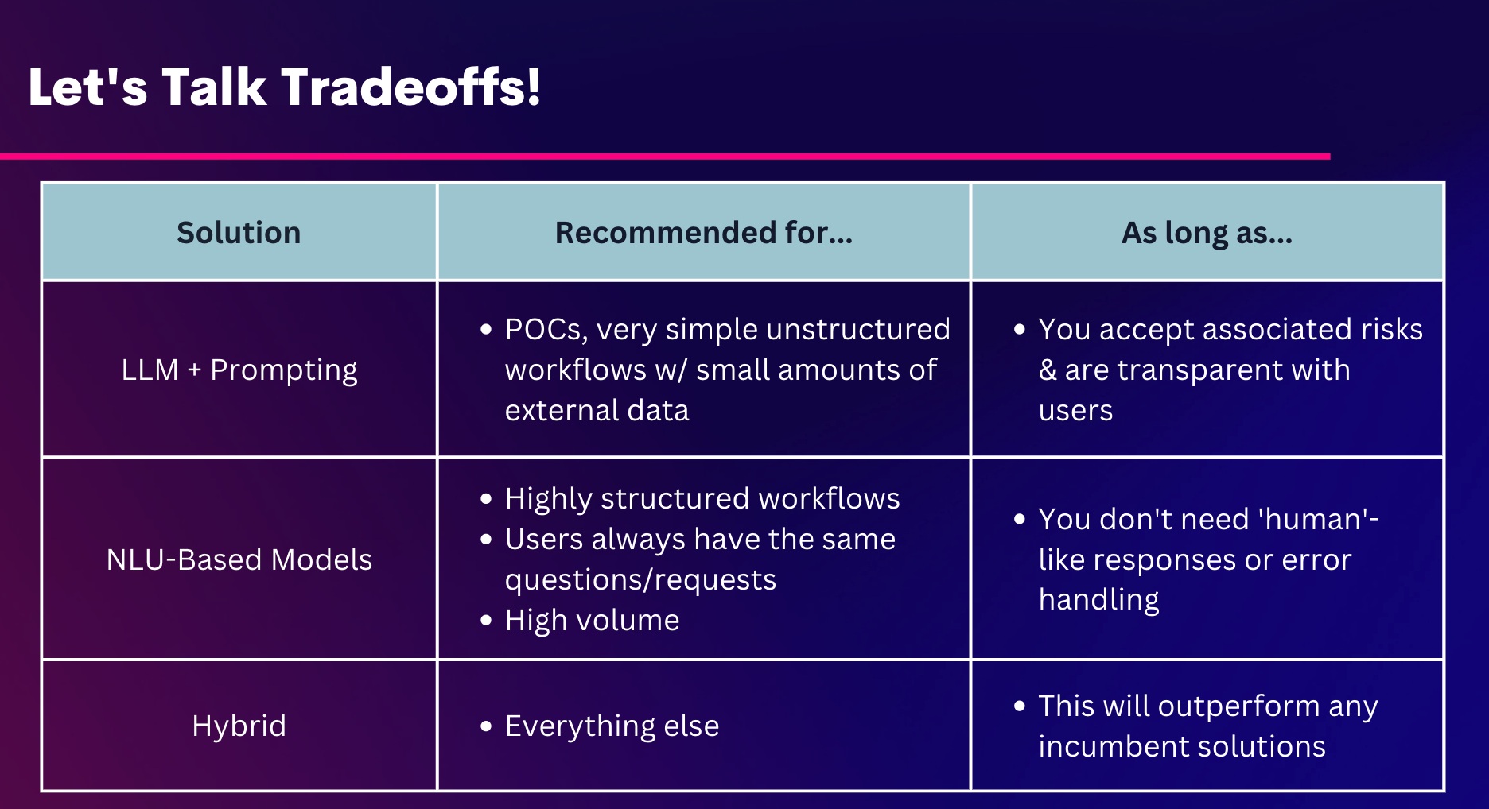
Let’s consider each of these:
- Use Case: Some use cases require stringent control over dialogue flows, like customer service interactions in heavily regulated industries, making NLU systems ideal. In contrast, more open-ended use cases like casual user queries can benefit from the flexibility of LLMs or Hybrid systems.
- Business Objective: If the objective is to provide a highly reliable service with consistent, controlled interactions, an NLU system might be preferred. For businesses aiming for rapid deployment across a broad range of topics and use cases, an LLM could be more effective.
- Conversation complexity: Simple, transactional conversations can often be handled effectively with NLU systems. In contrast, complex, nuanced, or wide-ranging conversation flows where users have diverse needs and diverse ways of expressing them may leverage the generative capabilities of LLMs more effectively.
- Accuracy needs: When accuracy and reliable fact-recall are paramount, NLU systems are the most reliable, but increasingly hybrid systems with RAG implementations are proving to provide the necessary precision. If the conversation can tolerate some degree of creativity or approximation, LLMs may suffice.
- Scale: For large-scale deployments where cost-effectiveness at volume is a priority, NLU systems can be more economical. However, if scalability needs to encompass a wide variety of topics and rapid content updates, hybrid systems might be preferred to handle new content and use cases more flexibly.
Given these factors, plus your goals and success metrics from Module 1, what approach would you select?

Recap
This guide walks readers through the different technical approaches to the back-end architecture of Conversational AI systems, and helps them select an approach based on the pros and cons of each approach, along with best fit according to their use case, business goals, and need to handle conversational complexity and scale.

Design a conversational UX experience

Overview
In this module, we will delve into basic technical concepts that form the foundation of a conversational AI user experience. We will explore how chatbots and AI copilots blend natural conversation with user interaction, a leap from the traditional UX approach of graphical user interfaces. We will dive deeper into the UX building blocks that define the core logic of a conversational UX flow including creating engaging starter prompts, using disambiguation and soft landings to avoid dead ends, and exploring the merits of defining personality traits of the AI.

What you'll do
- Understand basic technical concepts
- Create starter prompts
- Incorporate Disambiguation Logic
- Preempt failure cases
- Does your AI have a personality?
1

Understanding basic technical concepts
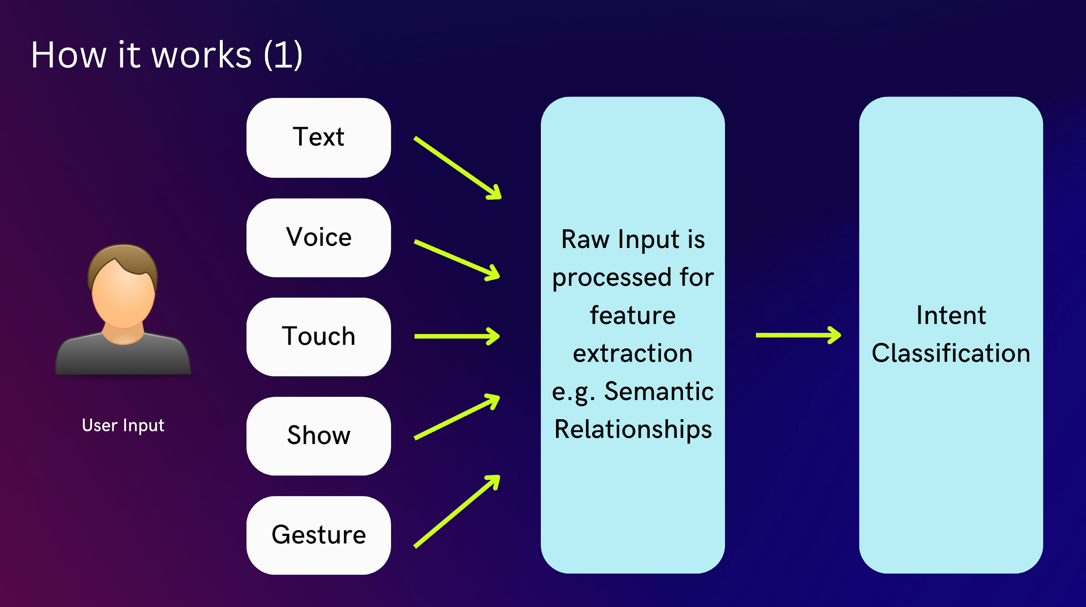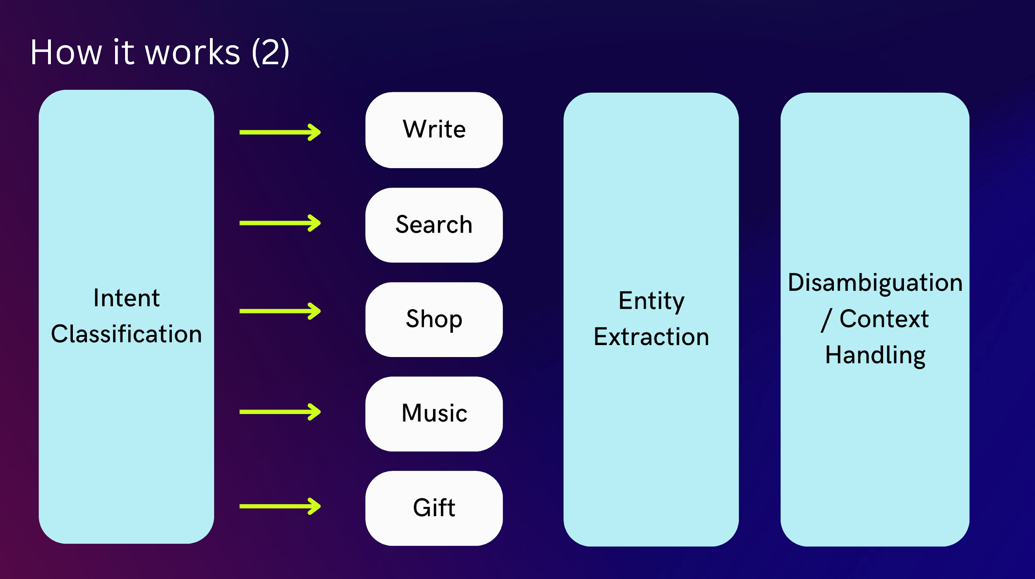

User Intent
Intent refers to the user's purpose or goal in a particular message. In this interaction, the user's intent can be identified as "Seeking Product Information," specifically for purchasing a waterproof tent for camping.

Entities
Entities are specific pieces of information that are important within the context of the user's intent. They are often nouns or noun phrases that the chatbot can recognize and use to provide a relevant response. In this case, the entities are:
- Product Category: Tents
- Product Feature: Waterproof
- Activity Type: Camping

Variables
Variables are the additional pieces of information that the chatbot needs to gather in order to provide a comprehensive response or to complete an action. They often correspond to the details that the chatbot asks for after identifying the user's intent and recognizing the entities. Here, the variables are:
- Size: The capacity of the tent, i.e., how many people it needs to accommodate.
- Seasonality: Whether the tent is required for summer or all-season use.
- Additional Features: Any extra preferences or requirements, like lightweight material or easy setup.

Context of Interaction
- User Message: "I am looking for waterproof tents for camping."
  - The user expresses a clear intent to find a product (waterproof tents) for a specific activity (camping).
- Chatbot Response:
  - The chatbot acknowledges the user's intent (search) and identifies the key entities ("waterproof tents" for "camping").
  - It then seeks to gather more information by asking about variables like size, seasonality, and additional features. This is to refine the search and offer more personalized recommendations.
This interaction demonstrates how conversational AI can facilitate an engaging and helpful shopping experience.
2

Create starter prompts
→ Start with the user goals.
The top user goals for outdoor gear shoppers as we defined in the user goals section in module 1 could be:
- 1) Finding the Right Gear: Find outdoor gear that meets their specific needs, preferences, and activities.
- 2) Receiving Personalized Recommendations: Seek personalized advice and product suggestions based on past shopping behavior or specific outdoor activities.
- 3) Efficient and Informed Purchasing Decisions: Users want to make quick, well-informed decisions with access to detailed product information, comparisons, and reviews.

→ Pick a goal and write starter prompts
These prompts are designed to engage the user right from the start, keeping in mind their primary goals in shopping for outdoor gear and leveraging the chatbot's capabilities to provide a personalized and delightful shopping experience.
→ Here are 2-3 example prompts to get the user started with the chatbot (choose anyone):
- "Hi, I'm your Outdoor Gear Assistant! Tell me about your next adventure, and I'll help you find the perfect gear. Are you planning for hiking, camping, climbing, or something else?"
- "Welcome back! Looking for more gear for your outdoor activities? Let me suggest some items based on your previous purchases. What type of gear are you thinking about today?"
- "Hello! Need help deciding on the best outdoor equipment? I can provide product comparisons, reviews, and detailed information. What product are you interested in today?"
Example |
Here's a sample conversation flow for one of the prompts we listed above:
Chatbot: Hi, I'm your Outdoor Gear Assistant! Tell me about your next adventure, and I'll help you find the perfect gear. Are you planning for hiking, camping, climbing, or something else?
User: 4 people, for winter camping and expecting some snow
Chatbot: For winter camping with snow, you'll need a sturdy, 4-person tent that's designed for colder weather and snow conditions. Here are a couple of options that meet your criteria:
- Arctic Explorer 4-Person Tent: This tent features a reinforced structure for heavy snow, with excellent insulation to keep you warm in winter conditions.
- Winter Haven 4P Snow Tent: Designed for winter camping, it offers robust snow-load resistance and a thermal layer for extra warmth.
Would you like more details on these tents, or would you need any other winter camping gear?
At this point, the conversation could branch into several directions based on user response (flexible UX).
Here are a few potential paths:
Path 1: User seeks more details about a specific product.
User: Tell me more about the winter haven 4P snow tent.
Chatbot:
Absolutely, I'd be happy to provide more details about the Winter Haven 4P Snow Tent. Here's what makes it a great choice for your winter camping adventures:
- Durability and Design: The tent is constructed with high-strength, weather-resistant materials, ensuring it can withstand heavy snowfall and strong winds. It features a geodesic dome design for extra stability in harsh weather conditions.
- Insulation: It's equipped with a specialized thermal layer to provide excellent insulation, keeping the interior warm even in low winter temperatures.
- Capacity and Comfort: Designed for four people, it offers ample space with an interior height of 6 feet, making it comfortable for both sleeping and daytime activities. The tent also includes storage pockets and a vestibule area for gear.
- Easy Setup: Despite its robust construction, the tent is designed for easy setup with color-coded poles and a user-friendly instruction manual. It's also relatively lightweight, making it a good option for winter backpackers.
- Additional Features: The tent has multiple ventilation points to prevent condensation, a snow skirt for extra protection, and reflective elements for visibility in snow. Would you like to view images or videos of the tent setup? You can also ask me any specific questions on pricing or availability
Path 2: User wants to explore a different product.
User: Can you recommend sleeping bags too?
Chatbot:
Certainly, I can help with that! For winter camping, it's important to have a sleeping bag that provides sufficient warmth and comfort. Based on your interest in winter gear, here are a couple of sleeping bags that are ideal for cold weather camping:
- FrostGuard Arctic Sleeping Bag: This is a mummy-style sleeping bag rated for temperatures as low as -20°C (-4°F). It features a water-resistant outer shell, a plush inner lining for extra warmth, and an adjustable hood for heat retention.
- EverWarm Down Expedition Bag: Perfect for extreme winter conditions, this sleeping bag has a temperature rating of -30°C (-22°F). It’s filled with high-quality goose down for insulation and has a durable, water-repellent exterior. It's also lightweight, making it easy to carry on winter treks.
Would you like more details such as weight or price? You can also ask me for related gear for your winter camping adventure.
Path 3: User wants to make a purchase
User: I want to buy the winterhaven tent and the everwarm sleeping bag
Chatbot:
Fantastic choices! The Winter Haven Tent and the EverWarm Sleeping Bag are excellent for your winter camping needs. Let's proceed with your purchase:
- Winter Haven 4P Snow Tent:
  - Price: [Insert Price]
  - [Summary of any additional details like color, weight and availability etc.]
- EverWarm Down Expedition Bag:
  - Price: [Insert Price]
  - [Summary of any additional details like color, weight and availability]
To complete your purchase, just type add to cart.
3

Incorporate disambiguation logic
Incorporating disambiguation into conversation flows enhances the user experience by enabling the AI to better understand user intent and provide accurate, relevant responses.
Consider adding disambiguation to your conversation flow in the following situations:
- Ambiguous user queries: When users provide incomplete or unclear information, disambiguation helps the chatbot ask clarifying questions to better understand the user's intent.
- Multiple potential matches: If the user's input could apply to multiple options, disambiguation helps the chatbot offer a list of relevant choices for the user to select from, ensuring the appropriate action is taken.
- Context-dependent requests: In cases where the user's query depends on the context or previous interactions, disambiguation allows the chatbot to gather more information to provide a relevant response or action.
- Avoiding errors and misinterpretations: Disambiguation can help prevent errors by verifying user intent before the chatbot proceeds with an action, ensuring user satisfaction and avoiding frustration.
- Complex workflows or processes: When the conversation involves intricate processes or multiple steps, disambiguation can help clarify user input and navigate the conversation more effectively.
So for our use case of an outdoor gear shopping chatbot, let’s consider how we could add disambiguation to the conversational flow.
User: What sleeping bags do you recommend?
At this point, the chatbot needs to determine which sleeping bags to offer. Here are some disambiguation examples:
Chatbot:
Disambiguation example 1 - I see you're preparing for winter camping with snow conditions. For your sleeping bag, would you prefer synthetic insulation which performs well in wet conditions, or down insulation which offers better warmth-to-weight ratio but requires dry conditions?
Disambiguation example 2 - Given that you'll be camping in snowy conditions, are you looking for sleeping bags with specific winter features like an integrated hood, draft collars, or extra foot warmth?"
Disambiguation example 3 - For your winter camping trip expecting snow, is the weight of the sleeping bag a major consideration for you? Are you looking for something ultra-lightweight, or is warmth your primary concern even if the bag is a bit heavier?
4

Preempt failure cases
Consider preempting edge cases or failure scenarios that might occur during the user-chatbot interaction and adding soft landings to the conversation flow.
Soft landings improve interactions with chatbots, making them more empathetic and engaging. This approach helps maintain a positive connection, even when facing challenges, leading to greater user satisfaction and trust in the chatbot.
Here are some scenarios for when to add soft landings to the conversation flow:
- Unrecognized user input: When the chatbot doesn't understand the user's input or can't provide a relevant response, a soft landing helps acknowledge the issue while maintaining a positive user experience.
- Unsupported features or requests: If the user asks for a feature or functionality that the chatbot doesn't support, a soft landing can gently inform the user about the limitation while providing alternative suggestions or guidance.
- Error recovery: In cases where the chatbot encounters an error, a soft landing can help acknowledge the issue, reassure the user, and guide them back to the main conversation flow.
- Dead-end situations: When the conversation reaches a point where it can't proceed further, a soft landing can help maintain user engagement by providing alternative paths, recommendations, or options.
- Sensitive topics or emotional situations: If the user expresses frustration, anger, or other strong emotions, a soft landing can help empathize with the user and direct the conversation towards a more constructive path.
Lets add a softlanding to our use case:
User: Where can I go camping during winter?
Chatbot: I'm here to help with gear recommendations, and while I don't have location suggestions, I recommend checking out local outdoor forums or national park websites for winter camping spots. Need any more help with camping gear?
5

Does your AI have a personality?
Or rather, does your AI need a personality? Consider the following before deciding:
Integrating a personality into a chatbot can significantly enhance user engagement. By crafting a chatbot with a distinct character, users often find their experience more engaging and enjoyable. This increased level of interaction can lead to higher user satisfaction, as the chatbot feels more like a conversational partner rather than a simple tool.
Moreover, aligning the chatbot's personality with your brand identity can play a crucial role in building and reinforcing your brand values. Such alignment ensures a consistent brand experience across various platforms, fostering a stronger connection between users and your brand. This consistency in interaction style and tone helps in establishing a clear brand image in the minds of users.
The addition of personality to chatbots also humanizes the interactions. Rather than a robotic and impersonal experience, a chatbot with a human-like personality makes interactions feel more relatable and comfortable. This human touch can lead to users forming an emotional connection during their interactions, enhancing the overall user experience.
In a market where differentiation is key, a chatbot with a unique personality can make your product or service stand out from competitors. This uniqueness provides users with a distinct and memorable conversational experience, which can be a deciding factor in a crowded marketplace.
Further, a chatbot that consistently exhibits a relatable and stable personality can be instrumental in nurturing user trust and loyalty. Such consistency ensures that users have a familiar interaction experience each time they engage with the chatbot, which can be reassuring and comforting.
Let's take a look at a few examples of how different personalities can create unique user experiences:
Let's rewrite the starter prompts in three different personality tones: professional, friendly, and humorous.
Professional tone:
Chatbot: Good day, I am your Outdoor Gear Assistant. Please share details about your upcoming outdoor activity, and I will assist you in selecting the appropriate gear. Are your plans related to hiking, camping, climbing, or a different activity?
Friendly tone:
Chatbot: Hey there! I'm your go-to Outdoor Gear Assistant. Excited to hear about your next adventure! Whether it's hiking, camping, climbing, or anything else, I'm here to help you pick out just the right gear. What's your plan?"
Fun tone:
Chatbot: Hey there, adventure buddy! 🌲 I'm your trusty Outdoor Gear Assistant, ready to gear you up for some fun! Hiking, camping, climbing, or maybe chasing waterfalls? Tell me all about it and let's get you kitted out for an epic time. What's your plan?
Example | →End-to-end multi-turn conversational UX flow for an outdoor gear shopping chatbot
- User: "Hi!"
- Chatbot: "Hello! Welcome to Adventure Gear. I'm here to help you find the perfect outdoor equipment. What are you looking for today?"
- User: "I need something for camping."
- Chatbot: "Great! Are you looking for camping tents, sleeping bags, or perhaps cooking equipment?"
(Disambiguation)
- User: "A tent."
- Chatbot: "Perfect. What size of tent are you interested in? We have options ranging from one-person to family-sized tents."
(Query refinement)
- User: "For two people."
- Chatbot: "Got it. A two-person tent. Do you have any preference for weight or seasonality, like lightweight or four-season?"
(Further query refinement)
- User: "Lightweight, for summer hiking."
- Chatbot: "Excellent choice! I have a few lightweight, summer hiking tents that would be perfect for two people. Would you like to see them?"
(Product selection)
- User: "Yes, show me."
- Chatbot: [Displays selection of tents] "Here are our top picks for lightweight, summer two-person tents. Do you have any specific questions about these options?"
(Product questions)
- User: "Does the Alpine 2 model have a mosquito net?"
- Chatbot: "Yes, the Alpine 2 model comes with a built-in mosquito net. It's also made with waterproof material and has excellent ventilation for summer hikes."
- User: "I'm worried it might be too small."
- Chatbot: "I understand your concern. The Alpine 2 has a floor area of 30 square feet and a peak height of 42 inches. Would you like to see the dimensions of other models for comparison?"
- User: "Yes, please."
- Chatbot: [Displays information] "Here are the dimensions of similar models. You can compare to see which one fits your needs best."
(Soft landing)
- User: "I think I'll need to think about it."
- Chatbot: "Of course, take all the time you need. If you have any more questions or need further assistance, feel free to reach out. We're here to help make your outdoor adventures amazing!"

Recap
By completing this guide, you will have an understanding of the foundational technical concepts that can help you appreciate the capabilities and limitations of the technology you are working with. You will have a scalable and customizable framework to build an end to end conversational user experience (UX) flows, which can be deployed for any project you are working on be it chatbots, copilots or voice interfaces. You should be able to conduct user testing and validate your hypotheses using these conversational ux flows.

Develope, Deploy & iterate Coversational AI System

Overview
Launching an AI-powered product is just the beginning of the journey. This guide covers architectural choices, engineering considerations, and post-deployment practices essential for successfully developing, deploying, and continuously improving conversational AI systems. We’ll provide frameworks for choosing conversational architectures, tools for prototyping, and techniques for evaluating model accuracy and performance. By the end of the guide, you’ll be equipped to shepherd your conversational product through deployment, launch, and beyond.

What you'll do
DEPLOY focuses on development, deployment, and ongoing improvement. You’ll get to:
- Evaluate Architecture Options: Understand architectural patterns for conversational systems like traditional Natural Language Understanding (NLU) based systems, standalone Large Language Model (LLM) chatbots, and hybrid approaches.
- Build a Prototype: Get hands-on with tools like Amazon Lex, OpenAI Playground, and Voiceflow.
- Set Evaluation Criteria: Define metrics and benchmarks for assessing performance.
- Launch, Monitor, Evaluate, Enhance: Learn techniques for monitoring, catching data drift and continuous improvement post-launch.
You’ll have the chance to build a simple conversational prototype using one of several tools that we’ll demo during our live session.
1

Evaluate Architecture Options
There are 3 main architectural approaches for developing conversational AI systems:
- Traditional, rules-based Natural Language Understanding (NLU) systems
- Standalone Large Language Model (LLM) chatbots like ChatGPT, Claude or LLAMA 2
- Hybrid systems that combine the NLU and LLM components to get the best of both worlds: the control and specific responses you want using NLU approaches, and more diverse, creative and human-like responses possible using LLMs.
Let’s look at these approaches in more detail.
1. NLU Systems use handcrafted rules and logic to determine conversation flow. These systems still use machine learning at various points, such as
- Automated Speech Recognition (ASR)
- Classifying the user’s INTENT (what kind of request they are making, eg. ‘What is the weather?’ vs. ‘Turn on the lights!’)
- Extracting ENTITIES (objects information to complete the request, eg. Seattle in the request, ‘What is the weather in Seattle’) from speech
- Text to speech (TTS) systems that correctly create audio to ‘read out’ text answers from the underlying system.
However, the logic of conversation flow, context tracking and calling out to 3rd party systems as needed is usually all designed before the system is ever deployed to users, with programmatic control over these systems. These systems have fallen out of favor with the dramatic adoption and popularity of LLMs. They are resource-intensive to set up and keep up to date, as they involve highly-specified dialog flows for each use case you want to handle. However, they do have several advantages:
- More control over conversation flow and responses: these systems’ conversations are hand-written and pre-vetted. Any unintentional bugs or errors can be corrected directly.
- Inexpensive to run at scale: Once set up, the per-utterance and per-conversation costs can be dramatically lower than LLM-based systems.
2. Standalone Large Language Model chatbots, like ChatGPT itself, are black boxes: there are no sub-systems responsible for different parts of the conversation flow, and the model itself provides natural language understanding, context handling, conversation state tracking, dialog management and response generation - all on one model. It is worth nothing that ChatGPT’s latest ‘voice-enabled models’ are really several models working in concert: their newly-released ASR model provides speech-to-text capabilities, while their TTS model Whisper provides text-to-speech. The advantages these systems offer include: However, in practice they have proven largely impractical for enterprise use cases because of their downsides:
- Handling of a broad variety of use cases with very little implementation effort
- Human-like flexibility in responses and dealing with unanticipated user requests
- Hard to control response quality - hallucinations, logic, bias; not easily constrained to particular set of data
- Expensive compute costs at scale
3. Hybrid systems combine rules-based and LLM components to get the best of both worlds. In a hybrid architecture, designers have granular control to decide whether each step of the conversation should be handled by an NLU system classifying intents and entities, or delegated to an LLM to generate freeform responses. The advantages these systems offer include:
- more flexibility than pure NLU solutions, while maintaining more control per conversation step than pure LLM solutions
- cost efficiencies: by caching answers for common questions, and relying on generation for novel or infrequent questions, these systems can provide drastic lifetime cost savings
Techniques like Retrieval-Augmented Generation (RAG) take hybrid implementations further by allowing designers to dynamically construct LLM prompts on the fly from relevant knowledge sources. Rather than solely relying on a static training corpus, RAG enables pulling personalized facts like a customer's purchase history into the LLM prompt powering the next step in the conversation.
Overall hybrid solutions offer conversational designers the ability to craft a tailored solution combining programmatic control and flow with LLM-generated responses as needed. This balances flexibility in handling diverse user requests with control over critical junctures to ensure the chatbot adheres to corporate policies, and maintains accuracy and appropriateness. The downsides are that they are more complex to develop than purely LLM-based systems; the lifetime development costs tend to fall between pure NLU and pure LLM solutions.
Choosing the right architecture depends on your use case, business objective, conversation complexity, accuracy needs, and scale.
Common Mistake
- Don’t assume LLMs are a silver bullet applicable to every use case. For example, if you have a user base with a narrow set of use cases easily handled by a simple NLU system, especially for high volumes of interactions, LLMs may be far more costly while providing little additional benefit over an NLU system.
- Don’t forget to account for long-term scale and engineering needs. Consider future scale needs - LLMs get expensive. Early prototyping phases are a great opportunity to leverage the ease of development of LLM-based solutions to validate user response, but understand that long-term, your architecture choices might change.
2

Build a Prototype
Based on the architecture you’ve selected in Step 1, select which tool you’d like to use to create a prototype. We’ll be walking through a demo of creating a chatbot with each interface in class.
Note: these are far from the only tools available for prototyping or developing chatbots for each architecture! These guides are designed to give you a flavor of the different approaches and complexity involved, while relying purely on no-code tools.
1. Building an NLU-Based Chatbot with Amazon Lex Amazon Lex, and other services like it (Google’s Dialogflow, Windows’ Azure Bot Service, or IBM’s WatsonX Assistant) help you build conversational interfaces using traditional NLU techniques for classification and intent routing. With Lex, developers can map out the structure of their conversational interface visually using the AWS console.
Key steps include:
- Defining the intents supported by your chatbot, like BOOK_FLIGHT or CHECK_WEATHER.
- Specifying sample utterances for each intent that capture the variety of ways users might trigger that intent. This trains an intent classifier model.
- Identifying any entities, like flight dates or city names, that are required to fulfill different intents. This trains entity extraction models.
- Mapping dialog flows between intents using a visual conversation builder. For example, booking a flight may involve confirmation of the departure city intent before eliciting the destination city intent.
- Adding custom fulfillment logic to tie intents to backend actions like checking flight prices or querying a weather API.
Once defined in the console, the Lex chatbot can be integrated into customer-facing applications through SDKs for platforms like web, mobile, and voice assistants. Lex handles classifying user input to determine intent, extracting any entities, executing any fulfillment logic, and managing the conversation flow.
2. Building a Standalone LLM-Based Chatbot with OpenAI Playground The OpenAI Playground provides a simple web interface for trying out conversational prompts with ChatGPT and other OpenAI models. It allows designers to quickly test drive and iterate on conversational experiences.
With the Playground, users can:
- Compose conversational prompts representing a given scenario or dialog flow they want to test. For example: "Act as a polite teacher answering student questions about biology."
- Configure parameters like model selection (ChatGPT vs GPT-4), temperature (think of this as model ‘creativity’), or max tokens (answer length) to control the creativity vs focus of responses.
- View AI-generated responses to their prompts, allowing rapid iteration to improve responses.
- Optionally sign up for an API key to programmatically send prompts and receive responses from a web API - which can then be integrated into other products.
The Playground offers a low-code way to prototype and experiment with OpenAI models. Users can craft and refine textual prompts to capture a given persona or dialog flow. This prompt engineering is the primary mechanism for directing model behavior.
However, the Playground provides limited control beyond prompts. There is no ability to connect to external data sources or implement custom fulfillment logic. The Playground is optimal for low-risk proof-of-concept testing before investing in custom LLM integration. But for more advanced use cases, custom development will likely be required.
Interested in taking this approach a step further with model fine-tuning? This approach actually trains a new model, based on an existing model like GPT-3.5-turbo, with your own conversational data examples. Training your own model does require working (at least a little) with code however. For those brave enough to venture there, see our Google Collab Notebook with instructions - just insert your own OpenAI API key and training data. Note that even OpenAI call out that fine-tuning works best in tandem with prompt engineering - you’ll get the most ROI for your effort in providing instructions rather than fine-tuning a model.
3. Building a Standalone LLM-Based Chatbot with Voiceflow Voiceflow provides a visual tool for developing conversational apps that combine structured NLU dialog flows with AI-generated responses powered by large language models.
With Voiceflow, developers can:
- Visually map conversations as a series of linked blocks that represent different states.
- Define intents that classify user input using sample utterances, similar to Lex.
- Connect API integrations to external data sources.
- Generate dynamic responses using LLMs like GPT-3.5-turbo or GPT-4
- Upload their own documents in multiple formats to a ‘Knowledge Base’, where your chatbot can retrieve information using RAG functionality
- Iterate rapidly via built-in testing tools
Voiceflow’s visual builder and intent editor lower the barrier for non-technical users. But advanced integrations, custom components, and governance guardrails are still possible under the hood. Make no mistake: you can develop a prototype, but many companies use Voiceflow for enterprise grade chatbots.
Tip |
- Get hands-on with at least two of the tools above (or alternatives) to evaluate fit and solidify the complexity handed by each kind of system
- Which tool is the right one for the job might depend heavily on your stage of development! For quick customer validation, consider a quick-and-dirty LLM approach. But be sure you consider what guardrails you need to put in place to handle hallucinations and biased or inappropriate responses.
3

Set Evaluation Criteria
Evaluation criteria for conversational systems, particularly when LLMs are part of the equation, is a rapidly evolving topic - determining if a system is correct or not can be challenging when there is often no one right answer! Regardless of the challenges, rigorously defining your evaluation framework upfront is critical for building high-quality conversational AI systems.
You need to assess both the technical and business impact, looking at both:
- Metrics whose measurement can be automated, and
- Metrics that require human evaluation.
High quality human ratings, while more expensive and difficult to get, serve as ground truth to validate automated metrics.
Metrics can be further broken down based on whether they evaluate:
- Per turn or dialog: each request and response
- Per conversation: the end-to-end conversation
- Per user: evaluation metrics can span multiple conversations to determine user impact
Below we’ve categorized some common evaluation metrics used for conversational experiences at Alexa, which we’ll review in class.
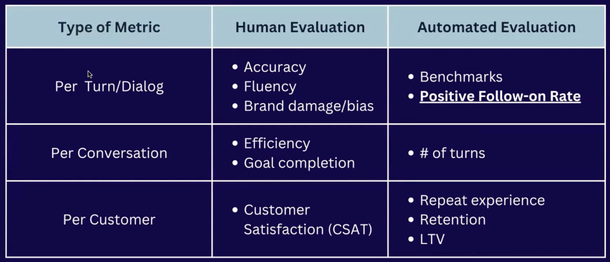
Consider using some open-source benchmarks for evaluating your conversational experience as well.
Example |
- Some example benchmark datasets for evaluating question-answering (QA) systems are listed below. There are constantly new benchmark datasets emerging - and question answering is not the only task you want to benchmark! For more examples, you can browse an extensive repository at Hugging Face. (Hugging Face is a French company that hosts a popular machine learning and data science platform & community, where many open source initiatives in AI are hosted and discussed). It includes benchmarks for text summarization and classification, for example - along with benchmarks for non-text tasks like multimodal model testing, vision and audio tasks.
QA Benchmark Dataset
SQuAD 2.0
- Stanford Question Answering Dataset focusing on real questions including unanswerable questions to challenge AI systems.
  - Link
TyDi QA
- A multi-lingual question answering dataset that includes languages with different typological characteristics.
  - Link
Natural Questions (NQ)
- A benchmark for training and evaluating open-domain question answering models, comprising real user questions and annotated answers from web pages.
  - Link
CommonSenseQA
- A benchmark for evaluating common sense reasoning in AI. The CommonsenseQA 2.0 challenges AI models further by testing their ability to handle adversarial examples and common sense errors.
  - Link
FACET
- A benchmark released by Meta to evaluate fairness in AI models, particularly in the domain of computer vision.
  - Link
SciQA
- A scientific question answering benchmark to evaluate QA systems based on the type of queries they can handle, including text documents, knowledge graphs, relational databases, or image archives.
  - Link
Common Mistake
Don’t underestimate the importance - or the effort involved in - establishing human review guidelines. This can be a time-consuming process that requires iteration. If possible, get internal team-members to stress-test guidelines ahead of crowdsourcing or paying for third-party annotation services.
Don’t focus on technical metrics at the expense of product or business metrics. Have a well-founded hypothesis about how your technical metrics are related to product and business goals and how they drive user value.
Don’t forget - evaluation continues after launch! Too many teams fail to plan for post-launch evaluation and monitoring. Model drift is a well-studied phenomenon where models get less accurate over time as underlying patterns in data change from the data they were trained on.
4

Launch, Monitor, Evaluate, Enhance
Getting to launch is just the beginning! Evolving your model involves:
- SYSTEM DEVELOPMENT (Iterate - Evaluate - Iterate - Evaluate!)
In the development stage, you need to plan for an iterative cycles of building, evaluating, and enhancing your conversational AI system. The evaluation results should directly feed back into the next iteration of development.
- LAUNCH and DEPLOY
Achieving ‘offline’ criteria like accuracy, fluency or goal completion rates in user testing is a great milestone, but you’ll usually have to determine if your system shows positive improvements to product and business metrics using A/B testing. Depending on how many users actually use your feature, and how large a difference in impact you expect between your existing system and the one you’re launching - gathering enough data to show positive impact can be frustratingly slow. Live system deployment can take weeks to months! Be sure to work with your science team to establish likely testing time needed to set appropriate expectations.
- reDEPLOY
You likely want to capture user feedback and use it to retrain your model - isn’t that the promise of machine learning, after all? Continuously improving system performance? However, many teams leap to over-engineering feedback loops (which are complicated and expensive to implement and support) without asking a key question:
→ How long will it take for you to get enough feedback to learn from?
You’ll need to carefully evaluate whether your expected user volumes will provide enough conversational data to significantly enhance the model via retraining. Often teams find that taking feedback offline and retraining on a quarterly or even yearly cadence is all that’s feasible.
Regardless of how often you plan to re-train your systems, factor in the end-to-end timelines for retraining on new data, testing new models, and re-deploying updated models. You’ll need to monitor conversational quality metrics, perhaps sampling some for occasional human evaluation to continue validating your automated metrics are valid. Schedule regular check-ins to assess conversation quality over time - this can be part of your weekly, monthly or quarterly business review cycle. If conversational quality is dipping, you’ll know how long it will take to retrain to avoid further system quality degradation.
Common Mistake
- Do not underestimate the engineering effort required to get an AI system deployed and production-ready. Data pipeline engineering along with model deployment testing for latency and stability can take just as long as the development of an AI model - if not longer! Work closely with engineering leaders early to understand deployment timelines.

Recap
Thoroughly evaluate architecture options and choose tools fit for your use case and team skills.
Do experiment with proofs-of-concept or prototypes while examining what kind of technical solution is a best fit for your use case.
Establish clear, measurable evaluation criteria before starting development.
Plan ahead for monitoring, updating, and enhancing models post-launch. Successful deployment is just the beginning!

Define Success of conversation AI system

Overview
With the mass adoption of ChatGPT, conversational AI and conversational user interfaces have garnered increasing attention as powerful tools for human-machine interactions. Whether it's voice-activated assistants, text chatbots, or more intricate AI-driven communication tools, the potential to reshape businesses is immense. However, with great power comes great responsibility. Let’s explore how to choose the right projects for conversational AI, align them with business goals, plan your data use, and manage potential risks. We'll guide you through selecting the best use cases and keeping stakeholders involved and informed throughout the project. By the end of this guide, you’ll be equipped to define your conversational AI product requirements in a way that steers clear of common pitfalls.

What you'll do
- Evaluate Use Cases for Conversational AI: Understand how to assess the fit of conversational AI for specific business goals.
- Define Business and Product Success: Identify business goals and success metrics and ensure your product success criteria support them.
- Define your Data Plan: Choose the right data sources and consider privacy and security implications.
- Conduct a Stakeholder Impact Assessment to Build a Risk Register: Recognize stakeholders to flush out, evaluate and manage risks associated with AI.
At the end of this content, you can implement these concepts by creating your own product requirements document (PRD) for a conversational AI project, including the Data Plan, Stakeholder Impact Assessment, and Risk Register.
1

Evaluate Use Cases for Conversational AI
First, it is important to define what we mean by ‘conversational experiences’ and ‘conversational AI’. Conversational experiences mimic human interaction using language in a multi-turn conversation flow. Conversational AI supports these experiences - whether just one part of the conversation flow (like understanding a user’s statements and extracting meaning from them) or orchestrating the entire conversation, including understanding the user’s statements, keeping track of conversational flow and context, and generating responses (like OpenAI’s ChatGPT).
Large Language Models (LLMs) have also garnered attention for supporting other use cases that don’t necessarily mimic human conversation: for example, content generation for marketing as in Copy.ai, meeting note summarization like Fireflies.ai, or code generation like Github Copilot. In this course, we are focusing on conversational experiences and AI.
Not all use cases are a great fit for conversational interaction! Examples of successful conversational experiences usually fall into one of these categories:
- Replacing human interaction: e.g. customer service, sales, or product onboarding chatbots, AI assistants like Alexa or Google Home
- Open-ended search: users can ask questions rather than simply entering keywords, and can then refine or give feedback on the answers e.g. Bing Chat
- Complex, high-context, or exploratory tasks where users want or need input flexibility: For simple tasks, a traditional user interface may be the most familiar, convenient, and quick for a user. Conversation helps where users need the open-ended input allowed by language to explore, explain, and refine their requests. eg. Booking.com’s Trip Planner
- Optimizing for modality: some multi-step tasks may be simple to accomplish in a traditional UX on a computer or phone, but require multi-turn conversation if the user’s eyes and hands are occupied. eg. Incorporating voice recognition for safer, hands-free operations during activities like driving.
Tip |
Take into consideration different modalities such as voice, text, and visuals like images and video. Which will help the user accomplish their goal most efficiently?
Common Mistake
Don’t assume conversation is the best user experience for every task! Many leaders are falling into the trap of trying to apply ChatGPT’s interface to every use case, assuming it will guarantee adoption. In conversational experiences users need to think of what to type or ask and follow a conversation - both of which require mental effort and attention. Your solution needs to save users effort and time.
And, don’t assume the same user experience and conversational flow will work for either a text chatbot interface or voice interaction. As we’ll see in the next course content around designing conversational AI products, users interact very differently using different modalities.
2

Define Business and Product Success
Clearly identifying your top-level organizational goals is crucial to ensuring your product vision ladders up to business success. Start by analyzing with your leadership team whether your overall business aims to increase revenue, reduce costs, or accelerate growth.
- Revenue growth entails devising strategies to expand sales volume or dollar value per transaction.
- Cost reduction centers on containing or decreasing operating expenses through greater efficiency.
- Growth initiatives focus on rapidly expanding your user base or number of interactions, especially for newer businesses still finding product-market fit.
Once you have alignment on the prevailing business goal, thoroughly pressure test whether your proposed product vision and use case directly support achieving it. Begin by articulating the specific user pain points and friction your product alleviates. Then logically map how easing those pains translates into positive business outcome moves like higher conversion rates, lower churn, quicker call resolution times, etc. Quantify how you will track those metrics and the size of the expected impact. Get explicit signoff from leadership on the chain of logic before devoting extensive resources to product development.
It is easy to make hand-wavy assumptions that adding a conversational interface will automatically reduce costs or accelerate revenue growth. However, moving forward without hard data substantiating the projected business impact is risky. You may end up with great conversational capabilities that delight individual users but fail to demonstrably move the needle on overarching organizational goals. Grounding the product vision firmly to realistic, measurable outcomes will ensure continued leadership support and product-market fit.
Tip |
- Secure explicit alignment from company leadership on current top-level business goals before committing resources to a specific product vision.
- Be ready to clearly explain during project approval how your proposed product will directly drive towards established organizational revenue, cost, or growth goals based on quantified projections.
- Identify the product-level metrics you can tie to business outcomes to track your progress as the project progresses.
Common Mistake
Don’t jump into a detailed product vision centered around conversational AI - or, worse yet, starting implementation - before high-level business goals are defined and agreed upon. This can help avoid developing a conversational AI product simply because new generative technologies like ChatGPT are grabbing headlines.
Don’t make assumptions that adding conversational interfaces or AI features will automatically reduce costs or accelerate growth without backing up those claims with user validation and analytical data.
3

Define your Data Plan
Since AI projects rely on patterns in data to make predictions and decisions, it only makes sense data planning should be a more prominent part of your product requirements specification. This is especially critical for Conversational AI projects. Be sure to address the following four key data areas:
- Knowledge Determine what knowledge sources your system will leverage to power its capabilities. Key options are internal content like support documentation or external sources like third-party websites. Define the specific documents, websites, databases etc. that will provide the facts and information your system needs.
- Conversation Decide what kinds of user conversations are appropriate or inappropriate for your system. Specify guidelines for how the system should ideally respond to various user questions and inputs. Identify any phrases, keywords or question categories that are off-limits.
- Evaluation Develop a process for evaluating the correctness and appropriateness of your system's responses that you will use during testing. Will you rely on human review and judgement? Can you identify or create benchmark datasets that model good vs. bad responses? What datasets do you have - or can you create - to model ideal and inappropriate systems?
- Feedback and Learning Consider whether and how frequently your system will learn from real user interactions once live. Determine the volume and frequency of retraining required to integrate user feedback effectively.
Thoroughly evaluate any licensing, security and privacy requirements for your planned knowledge sources and conversation data. Initially, it can make sense to prioritize fully owned, vetted first-party data to limit legal risks. Remember to think about the full lifecycle of your project, including post-deployment and maintenance - you’ll need to continuously update and monitor all four data areas above to maintain quality bars.
Example | Claude
As Large Language Model-based chatbots emerge, it has become common industry practice to share information about the data used for training and evaluation, and the policies it adheres to, in a “Model Card”. These serve as great examples of how data plans get documented. You can see the Model Card for Claude, Anthropic’s competitor to ChatGPT, here: https://www-files.anthropic.com/production/images/Model-Card-Claude-2.pdf
Tip |
- If your organization is new to conversational AI, look at proprietary first-party data sources first to minimize licensing uncertainties.
- Be sure to include plans for scrubbing customers’ personally identifiable information like names, addresses, phone numbers, and email addresses from content like call transcripts, etc. if you are using these for training or evaluation.
- Plan a human review process to filter inappropriate conversations from training data. These can be time-consuming!
Common Mistake
Don’t assume unrestricted rights to use external websites and social media content. Just because you CAN crawl this content doesn’t necessarily mean you have the rights to use it in your products or systems. Consider the current legal issues OpenAI is facing with respect to copyright and fair use.
Don’t underinvest in systematic processes to catch bad training examples that violate policies or brand voice. Often, these can be rare in your data, and hard to detect systematically. Clear guidelines, with examples of good, bad, and grey-area answers will help evaluators’ accuracy.
4

Conduct a Stakeholder Impact Assessment to Build a Risk Register
Responsible AI has gotten a negative reputation as a bottleneck riddled with slow, bureaucratic processes - but it doesn’t have to be that way! While there are many government and industry guidelines on Responsible AI best practices, these can largely captured and managed using two best practices: a Stakeholder Impact Assessment and a Risk Register. Depending on the scope of your project or program, this can take multiple sessions over a week - but for many feature-level initiatives, this can be established in as little as a few hours with the right stakeholders in the room.
1. Stakeholder Impact Assessment
Start by enumerating all groups positively or negatively affected by your AI system, including:
- Users: Include subgroups you want to protect against the potential negative effects of biased data. Consider distinguishing groups that may face discrimination by gender, ethnicity, age, etc.
- Developers: What are the potential harms and benefits to those developing the system?
- Indirect players: Consider data providers and human annotators.
- Society: include considerations like systemic misinformation dissemination and climate impacts.
Analyze the potential harms and benefits to each of the stakeholders above. The output of this exercise will be a list of potential risks you’ll want to prioritize, monitor, and potentially mitigate over the course of your project.
2. Risk Register
With your cross-functional team, develop a risk register listing all identified risks, including those that came out of your Stakeholder Impact Assessment. For each risk, your Risk Register should include:
- the likelihood of the risk (this can be a rating or a percentage)
- the severity (likely a rating, eg. Low/Medium/High)
- the owner: who owns this risk being handled appropriately?
- The next steps and specific mitigating actions.
Continuously update the register and display it prominently so new risks can be quickly added and tracked. Assign clear owners for each risk to coordinate mitigation efforts like securing legal sign-off on data sourcing or adding safeguards against toxic language. Prioritize high-probability and high-severity risks for immediate mitigation.
Don't wait for risks to materialize before planning for them. Proactively coordinate mitigation efforts through regular review of your risk register with representatives from legal, PR, engineering, and other groups. They will bring unique risk perspectives you may overlook independently. Keep iterating on mitigations as new risks emerge or original safeguards prove inadequate in practice. Resist complacency by continually challenging your risk assumptions through ongoing user studies and external audits.
Tip |
- Along with technical and product stakeholders, Involve representatives from legal, PR, and marketing groups to get a 360-degree view to assess risks early and often
- Make a review of your Risk Register part of your project development rituals, like during sprint retrospectives & planning. This ensures risks are handled proactively and get attention throughout your project.
Common Mistake
Don’t leave Responsible AI and risk planning as an afterthought until late in the development process. Too commonly data science teams attempt tech-driven initiatives and ask product to ‘responsibilify’ it at the end.

Recap
- Clearly align product vision to business goals and incremental user value before committing development resources to any product - particularly conversational AI. Are you saving time and energy? Enabling user growth and retention?
- Thoroughly evaluate use cases, analyze incremental value, and think about all possible modalities (text, speech, and visual elements like video or images) when determining the best ways to meet user needs.
- Carefully assess data sources and mitigate risks early through cross-functional collaboration.

Tab 5

Overview
Generative AI can enhance your product's value levers in a few key ways:
- Streamlining complex UI through conversational flows
- Expanding the product's scope for a more cohesive, end-to-end solution
- Augmenting human capabilities to boost efficiency
- Producing hyper-personalized, multi-modal content
Successfully integrating generative AI into a product hinges on your ability to align AI capabilities with the product's primary value drivers. Product teams are often flooded with feature ideas and have to make decisions about which will provide the most value with imperfect information and technology that is advancing on a weekly basis. This guide will help product teams align generative AI capabilities with their product’s value drivers so they can formulate a high-impact value proposition.
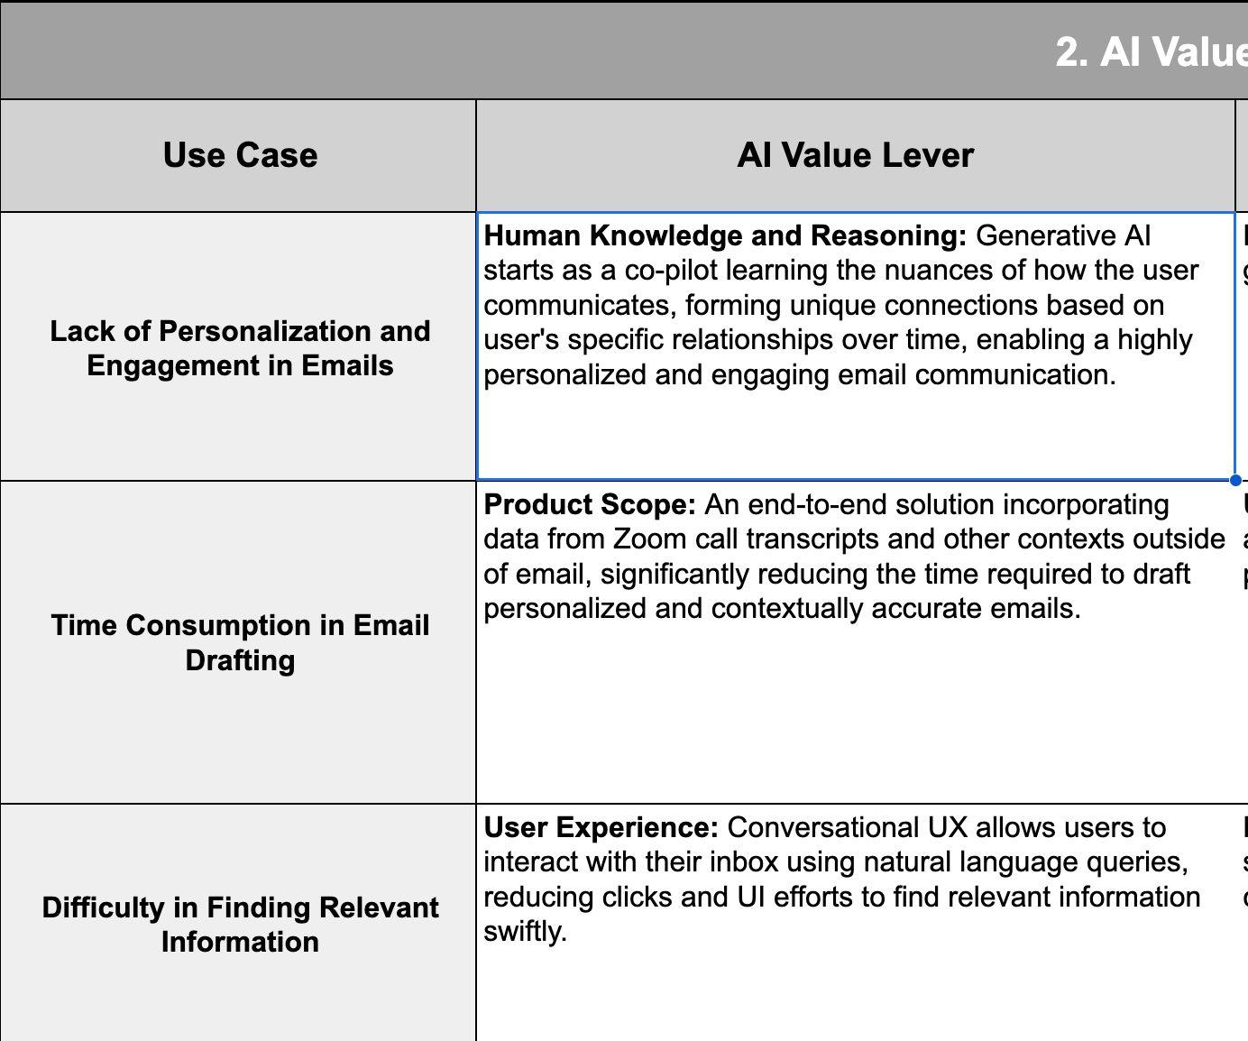

What you'll do
- Assess UX opportunities
- Determine product scope
- Evaluate opportunities to augment humans
- Investigate content generation opportunities
1

Assess UX opportunities
Arthur C. Clarke's famous adage is that "any sufficiently advanced technology is indistinguishable from magic." In the context of AI, the magic lies in the seamless, conversational experiences that technologies like ChatGPT can provide. The key question for product builders, however, is determining the extent to which a conversational experience is beneficial for your product.
A good starting point for this assessment is to examine the UX complexity for your product's core interaction flows. Conversational interactions have the potential to eliminate friction, making it easier for users to accomplish a task. To do this effectively, both qualitative and quantitative analyses should be employed.
- Qualitative assessment: Apply the Psych Framework by Darius Contractor to map out the cumulative psychological triggers that cause users to take action in a particular flow and uncover opportunities where conversational AI can significantly simplify the process.
- Quantitative analysis: Analyze key conversion drop-offs and user behavior data across product surfaces prone to churn, such as product onboarding and search.
- By combining the insights from both qualitative and quantitative analyses, you’ll identify where conversational UI can significantly enhance your product experience.
Tip |
- Focus on rapid experimentation to validate value.
Common Mistake
Overlooking Visual Affordances: While text-based communication is the essence of conversational UI, integrating appropriate visual cues, like list pickers, carousels, and even emojis is crucial. For instance, Apple's Messages for Business uses such UI components to enhance the conversational flow, underscoring the importance of visual engagement.
Product-Channel Fit: As Brian Balfour notes, products are built to fit channels, not the other way around. Product teams should be careful to not just 'bolt on' a conversational UI to the lower right of the website. It's better to think about a stand alone experience like Brex does with WhatsApp or tight integration into Search as Reforge and Google Bard.
2

Determine product scope
Products are tools that meaningfully satisfy customer problems. Product scope refers to the extent your product solves a problem within a user journey or business process.
- Point Solutions: A point solution is a product or service designed to address a specific problem or fulfill a singular need in the business process.
- Compound Product: Require building multiple products in parallel in order to solve larger business problems that might span across distinct business systems. Historically this is much more challenging and expensive to execute on, but can provide greater growth and returns.
Generative AI makes it possible to increase the aperture of what problem(s) your product solves and create more value for users. Areas to assess opportunities around scope include:
- User Diversity: If the user base has a wide range of needs and problems, a compound product driven by Generative AI can be particularly beneficial. For example, an AI-driven business suite might handle email communication, schedule management, and financial forecasting simultaneously.
- Data Availability: Generative AI thrives on data. Unlike software engineering, generative AI provides non-linear value by providing solutions to a range of problems based on the data it has access to.
- Interconnectivity of Problems: If the problems faced by users are interconnected, a compound product can provide integrated solutions that offer more value than isolated point solutions.
- Feedback Mechanisms: To make the most of generative AI's capabilities, there should be robust feedback mechanisms in place. This helps the AI iterate and improve its solutions. For example, Otter.ai can expand for meeting transcription to a meeting coach that tracks if meetings are progressing to an agenda if it can capture quality feedback data on the utility of its suggestions.
Example | Glyphic.ai
Glyphic.ai is an AI powered sales tool that aims to solve the end-to-end workflow of a sales development representative: from capturing transcripts of sales calls to automating outbounds with fine tuned suggestions that propagate the relational context of the lead. Today, CRM tools like Pipedrive focus on managing outbounds (a single step in the process), enabling Glyphic to compete with a compound product.
Example | Notion AI
NotionAI integrated generative AI to streamline the writing and research process within the Notion platform. Instead of searching the internet separately before writing, users could research directly in Notion, providing an 'all-in-one' solution. By expanding the product scope and addressing interconnected problems in a user's journey, NotionAI elevated the value proposition of Notion, making it a compound solution that opened new monetization opportunities rather than just a point solution for the writing use case.
Tip |
It's crucial to deeply understand the customer problem space and market to best discern opportunities to redefine the product scope. The breadth and depth to which a product addresses these problems dictate its scope. Knowing where the most acute and frequent pain is and to what degree that is addressed by competing solutions is critical towards incurring the greater cost and complexity of a compound product.
3

Evaluate opportunities to augment humans
Humans in the loop are often important stakeholders in the value creation of products. You can identify high leverage opportunities for AI by measuring consideration, the amount of effort and know how required to make a decision in workflows involving humans. Evaluating consideration requires being clear on the nature and degree of human intellect required for a given use case.
Humans have a combination of two types of intelligence:
- Fluid intelligence: the ability to think abstractly to solve new problems
- Crystallized intelligence: the understanding of what ‘good looks like’ that comes from prior learning and experiences
Most AI language models possess amazing fluid intelligence but struggle with crystallized intelligence. For instance, while an AI could help analyze customer buying patterns on a Shopify store and even suggest marketing copy, it can't replicate the nuanced experience of a merchant who has managed operations for a decade and intimately knows their business levers.
For use cases leaning heavily on crystallized intelligence, generative AI can be a fantastic "co-pilot". Most knowledge work involves analyzing and transforming data, a task that AI is better suited for, which enables humans to focus their time on exercising good judgment. For example, GitHub Co-pilot assists developers by suggesting code snippets, allowing them to concentrate on the bigger picture and make strategic technical decisions in their projects.
Identify high leverage 'co-pilot' opportunities by answering 3 questions:
- Where in my product's workflows do users invest the most effort and expertise?
  - Focus on areas of your product where users frequently have to intervene, make decisions, or employ specialized knowledge. If there's significant human intervention in certain areas, these could be prime candidates for AI co-piloting.
  - Example: Curated is a platform connecting shoppers with experts for personalized product recommendations in high consideration categories such as winter sports. Imagine if an AI-backed system within Curated could amalgamate a customer's past purchase history, expert reviews, and Curated's extensive product database — all tailored to an expert's specific style and knowledge. With such a tool, an expert could offer personalized recommendations to shoppers with just a click. In this enhanced scenario, the best Curated experts can provide bespoke guidance to 1,000 customers rather than just 100.
- Which areas of my product involve extensive data handling, analysis, or transformation?
  - Identify parts of your product that revolve around managing vast data sets or require data-driven decisions. These areas could benefit greatly from AI's analytical prowess, optimizing processes, and suggesting insights.
  - Example: Shopify Sidekick acts as a co-pilot for merchants, streamlining their e-commerce experience with AI-driven insights. Drawing from vast datasets, Sidekick provides tailored support, enabling merchants to make data-driven decisions with ease. For instance, if a product's sales spike, a merchant can quickly consult Sidekick to understand the trend, then strategically adjust stock or marketing efforts based on the provided insight. This direct interaction simplifies complex data analysis, allowing merchants to focus on optimizing their business.
- How can AI intervention in my product transform current cost burdens into revenue opportunities?
  - Examine segments that currently represent significant costs, such as high- maintenance customer service sectors. Contemplate how AI can streamline these segments, enhance user engagement, and potentially introduce new revenue channels by offering more value or broadening the service scope.
  - Example: In traditionally 'back office' domains like customer service, generative AI can help humans transition from cost centers to revenue drivers. Currently customer service is viewed with overhead, the average cost per resolved interaction ranges from $40-$100, with Fortune 500 monthly ticket volumes >100k. Generative AI is creating 10x productivity efficiencies which is changing the paradigm such that customer service can be a human augmented engagement tool throughout a product's lifecycle. Instead of burying 'contact us' options, AI can empower companies to actively, and cost-effectively, initiate delightful customer interactions across a broader product scope.
Common Mistake
A common mistake product teams make is relying on prompting generic language models like ChatGPT, neglecting the need to train models on smaller, task-specific datasets and adjusting the model based on feedback (this is called fine-tuning). Consider the company Curated, which connects shoppers to experts for product recommendations. If a generic AI was used to give advice without understanding the unique insights of each expert, the recommendations would feel impersonal and lack depth. In contrast, when you fine-tune a model with proprietary data, it mirrors the specific style, tone, and depth of the human expert, making the AI a genuine "co-pilot" rather than just a tool.
4

Investigate content generation Opportunities
Great content has always been a lever for winning product and business outcomes:
- Content is the value: Engaging, high quality content ensures that users spend time on a product and return regularly.
  - For platforms offering learning services, such as Coursera or Khan Academy, the quality of content is directly tied to the product's core value. Users primarily engage with these platforms for their content, seeking to enhance their skills or knowledge
- Brand Trust and Credibility: Accurate and authoritative content boosts a brand's reputation. Websites like WebMD or Mayo Clinic provide reliable health information, making them go-to sources for users seeking medical advice, thereby elevating their brands' trustworthiness.
- Improved Conversion Rates & SEO: High-quality content tailored to user needs can drive action and ensure higher search rankings. For e-commerce platforms like Amazon, detailed product descriptions and reviews can influence purchasing decisions. Meanwhile, comprehensive blogs or articles can lead search engines like Google to rank a website higher, driving organic traffic, as seen with platforms like Medium.
It’s no surprise generative AI is highly effective at content. In 2021, less than 1% of the data was created using AI. Gartner predicts that by 2025, 10% of the data created on the Internet will be created using Generative AI technologies, and there are predictions that say that by 2030, 90–99% of the data on the internet will be created with the help of Generative AI technologies.
How can product and growth teams cut through the noise, ensuring their content not only reaches but also resonates with its target audience? The key lies in crafting hyper-personalized and contextual experiences that combine user data, application logic, and multi-modal generative AI.
Example | January.ai
January.ai, a CGM (Continuous Glucose Monitoring) company, recently launched an AI health coach which leverages ChatGPT in tandem with proprietary CGM data, users' health data, and insights from their partnership with Stanford Medicine. Their AI health coach provides bite-sized, actionable recommendations, effectively nudging users towards healthier decisions. Imagine a user—a woman who indulged in a slice of cake. Instead of generic advice, she receives a specific recommendation on the duration of a walk she should take to normalize her blood glucose levels, all based on her personal health metrics and past behaviors.
Common Mistake
- Taking a Short-Term View: Focusing solely on short-term quarterly OKRs can lead product teams to produce large volumes of generic content quickly to meet immediate targets. However, this can neglect long-term strategic initiatives, like enhancing content quality and relevance, which are essential for sustained user engagement and satisfaction.
- Not Personalizing: Settling for prompting instead of fine-tuning generative AI to your organization or specific user personas can result in generic, inauthentic content. Personalization, which involves training AI on your unique data and style, is crucial for generating content that truly resonates with users and enhances their engagement and trust.

Recap
Generative AI can meaningfully contribute to a product's core value levers by:
- Streamlining complex UI through conversational flows
- Expanding the product's scope for a more cohesive, end-to-end solution
- Augmenting human capabilities to boost overall effectiveness
- Producing hyper personalized multi-modal content
Assess UX opportunities by examining the role of search in your product. Products that rely heavily on search functionality could greatly benefit from AI-powered conversational interactions.
Determine product scope by assessing user diversity, data availability, interconnectivity of problems, and feedback mechanisms.
Augment human tasks with AI particularly in areas where users invest the most effort and expertise, extensive data handling, analysis, or transformation are involved.
Investigate content generation opportunities using generative AI to launch hyper- personalized and contextual experiences that combine user data and relevant 1st and 3rd party content.

